Functions in Python

Lesson Introduction
Today we will explore Functions in Python, a core building block for writing clean, reusable, and organized code.
We will cover:
- Function
- Built-in Functions
- User Defined Functions (UDFs)
- Defining & Calling Functions
- Parameters & Arguments
- return Statement
- Variable Scope
- Recursive Functions
- Anonymous Functions (lambda)
- Call by Value & Call by Reference (optional)

Real-World Hook
Question:
If you were baking cakes for 100 people, would you manually mix and bake each one from scratch, or create a recipe and repeat the process?
Problem:
When coding, repeating the same code again and again wastes time, increases errors, and makes maintenance difficult.
Solution:
Python functions act like recipes — once you define them, you can reuse them anywhere.

Introduce Topic as a Solution
Functions allow us to:
- Group related instructions into a single reusable block.
- Avoid repetition.
- Improve maintainability.
- Simplify debugging.

Theory Explanation

Function
a function is a named block of organized, reusable code designed to perform a specific task. Functions are fundamental for structuring programs, promoting code reusability, and improving readability and maintainability.
Key Concepts of Python Functions:
A function is a block of code that performs a specific task.
Suppose we need to create a program to make a circle and color it. We can create two functions to solve this problem:
- function to create a circle
- function to color the shape
Dividing a complex problem into smaller chunks makes our program easy to understand and reuse.

Types of Functions in Python:
- Built-in Functions: Predefined functions provided by Python's standard library, readily available for use without explicit import. Examples include print(), len(), int(), sum(), abs(), etc.

- User-defined Functions: Functions created by the programmer to perform specific tasks tailored to their program's needs.

- Functions Defined in Modules: Functions within Python's standard library modules (e.g., math.sqrt(), random.randint()). These require importing the respective module before use.

1. Built-in Functions
What:
Predefined functions available in Python (e.g., print(), len(), type(), sum()).
Why:
They save development time because they’re ready to use.
When:
When a built-in solution exists for a common task.
Example:
numbers = [1, 2, 3, 4, 5]
print(len(numbers)) # Output: 5
print(sum(numbers)) # Output: 15
Advantages:
- No need to define from scratch.
- Highly optimized.
Limitations:
- Limited to predefined functionalities.

2. User Defined Functions (UDFs)
What:
Functions created by the programmer.
Why:
To perform custom, repetitive tasks.
When:
When no built-in function matches your exact need.

Syntax:

Function Declaration
The syntax to declare a function is:
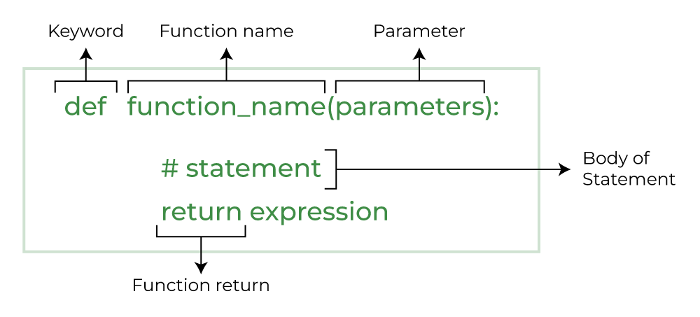

def function_name(parameters):
"""Docstring explaining the function"""
statements
return value

Example:
def greet(name):
return f"Hello, {name}!"

print(greet("Alice"))

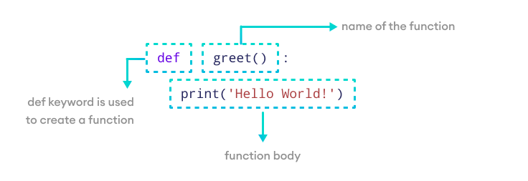
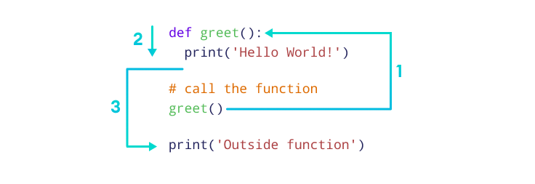

3. Defining & Calling Functions
- Defining: Use def keyword.
- Calling: Use the function name with parentheses ().
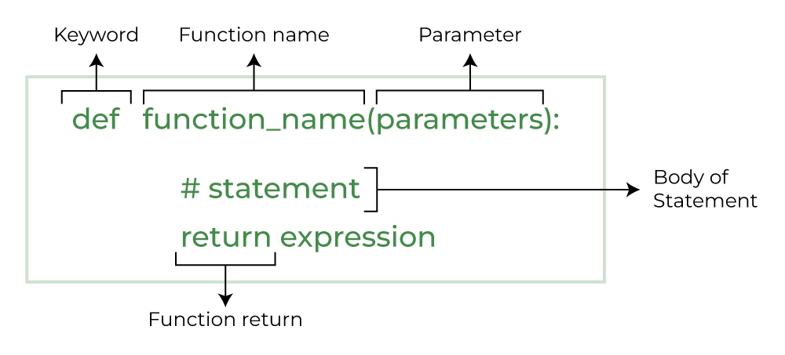
Syntax:
def function_name(parameters):
# function body
Explanation:
- def: Starts the function definition.
- function_name: Name of the function.
- parameters: Inputs passed to the function (inside ()), optional.
- Indented code: The function body that runs when called.
Example:
def add(a, b):
return a + b

result = add(5, 3)
print(result)

4. Parameters & Arguments
- Parameters and Arguments:
  - Parameters: Placeholders defined within the function's parentheses during definition (e.g., name in greet(name)).
Parameters are the variables listed inside the parentheses in the function definition. They act like placeholders for the data the function can accept when we call them.
Think of parameters as the blueprint that outlines what kind of information the function expects to receive.
def print_age(age): # age is a parameter
print(age)

  - Arguments: The actual values passed to the function when it is called (e.g., "Alice" in greet("Alice")).
Arguments are the actual values that we pass to the function when we call it.
Arguments replace the parameters when the function executes.
print_age(25) # 25 is an argument
Here, during the function call, the argument 25 is passed to the function.

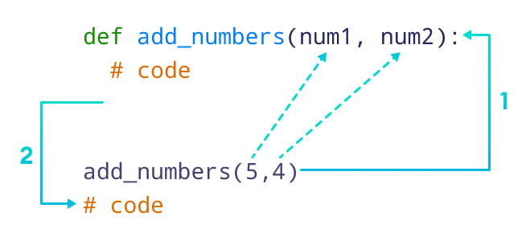
Types:
- Positional Arguments
def add(a, b):
return a + b
print(add(2, 3))

- Keyword Arguments
def greet(name, age):
print(f"{name} is {age} years old.")
greet(age=25, name="John")

- Default Arguments
def greet(name="Guest"):
print(f"Hello {name}")
greet()

- Variable-length Arguments (*args)
def total(*numbers):
return sum(numbers)
print(total(1, 2, 3, 4))

- Variable-length Keyword Arguments (**kwargs)
def info(**data):
for key, value in data.items():
print(f"{key}: {value}")
info(name="Alice", age=25)

5. return Statement
What: Sends result back to caller.
def square(x):
return x ** 2
result = square(5)

6. Variable Scope
- Local: Declared inside a function.
- Global: Declared outside all functions.
x = 10 # global

def test():
y = 5 # local
print(x, y)

test()

7. Recursive Functions
What: A function calling itself.
Example:
def factorial(n):
if n == 1:
return 1
return n * factorial(n-1)
print(factorial(5)) # Output: 120

8. Anonymous Functions (lambda)
What: Small, one-line function without def.
Example:
square = lambda x: x ** 2
print(square(4))

9. Call by Value vs Call by Reference
- Call by Value: Changes inside function don’t affect original.
- Call by Reference: Changes affect original data.
https://www.geeksforgeeks.org/python/python-functions/
Example:
def modify_list(lst):
lst.append(4)

nums = [1, 2, 3]
modify_list(nums)
print(nums) # [1, 2, 3, 4]

=============================
# Function modifies the first element of list
def myFun(x):
x[0] = 20

lst = [10, 11, 12, 13]
myFun(lst)
print(lst) # list is modified

# Function tries to modify an integer
def myFun2(x):
x = 20

a = 10
myFun2(a)
print(a) # integer is not modified

=============================

Benefits of Using Functions:
- Modularity: Breaks down complex programs into smaller, manageable units.
- Reusability: Avoids repeating the same code by allowing functions to be called multiple times.
- Readability: Makes code easier to understand and follow.
- Maintainability: Simplifies debugging and modifications, as changes can be isolated within functions.

Dataset for Practice (50 datapoints)
students = [
{"id": i, "name": f"Student{i}", "marks": i * 2 % 100}
for i in range(1, 51)
]

Practical Example
Task: Calculate average marks using a user-defined function.
def average_marks(data):
total = sum(student["marks"] for student in data)
return total / len(data)

print("Average Marks:", average_marks(students))

Business Scenario
A school’s grading system uses functions to:
- Calculate averages.
- Assign grades.
- Generate reports.
- Use recursion for nested evaluations (like cumulative marks).

Practice Session
- Write a function to return the square of a number.
- Create a function to find the maximum marks in students.
- Write a recursive function to calculate the sum of first N numbers.
- Create a function using *args to sum unlimited numbers.
- Create a function using **kwargs to print student details.
- Write a lambda function to check even or odd.
- Create a function with default argument to greet a user.
- Show the effect of modifying a list inside a function.
- Write a function that returns multiple values.
- Create a function to assign grades (A/B/C) based on marks.

Case Study – Student Performance Tracker
Scenario:
Build a Streamlit app to:
- Upload student data.
- Use UDFs to process and calculate results.
- Display top performers and statistics.
Streamlit Example:
import streamlit as st

def average_marks(data):
return sum(student["marks"] for student in data) / len(data)

students = [
{"id": i, "name": f"Student{i}", "marks": i * 2 % 100}
for i in range(1, 51)
]

st.title("Student Performance Tracker")
st.write("Average Marks:", average_marks(students))

Assignments
- Create a recursive function to calculate Fibonacci series.
- Create a grading function using lambda and map().

Quiz
- What keyword is used to define a function in Python?
- What’s the difference between *args and **kwargs?
- What is a recursive function?
- Give one example of a built-in Python function.
- What does the return statement do?

Recap
- Functions make code reusable and organized.
- Built-in vs User Defined Functions.
- Parameters, return values, scope, recursion, lambda.
- Real-world use in grading systems, reporting, and automation.

Resources
- Python Official Functions Docs
- Streamlit Docs

Common Interview Questions
Theoretical:
- Explain the difference between local and global variables.
- What is recursion and give a real-world analogy.
- Difference between positional and keyword arguments.
- Explain lambda functions and when to use them.
- Difference between call by value and call by reference in Python.
Practical:
- Write a Python function to reverse a string.
- Create a recursive function to calculate factorial.
- Write a function that takes a list of numbers and returns a new list with only even numbers.
- Use a lambda function with filter() to get marks > 50 from the dataset.
- Create a function that accepts any number of keyword arguments and prints them.

